**1. Introduction:**

This project focuses on an advanced image captioning framework, utilizing a Convolutional Neural Network (CNN) as an encoder and a Recurrent Neural Network (RNN) as a decoder. It aims to enhance caption quality in handling complex visual contexts.

**2. Need and Necessity of Project:**

Enhances accessibility by providing detailed descriptions, aiding visually impaired users. Improves content understanding and searchability.

**3. Objectives:**

1) To develop a deep learning-based image caption generator that can accurately describe the contents of an image in natural language.

2) To study the deep learning techniques like CNN and RNN.

**4. Methodology:**

Utilize EfficientNetV2 for image feature extraction, feeding the features into a GRU for image caption generation.

**8. Advantages:**

• Accessibility

• Content Retrieval System

**Disadvantages:**

• Overfitting

• Misclassification

**9. Application**

• Social Media

• Content Recommendation

• E-commerce

**10. Conclusions & Future Scope:**

Image captioning using EfficientNetV2 and GRU represents a significant advancement in the field of deep learning, with enhanced performance and demonstrates an efficient use of computing resources. The future scope involves optimizing model to generate captions on wide range of images.

**5. Block Diagram:**

**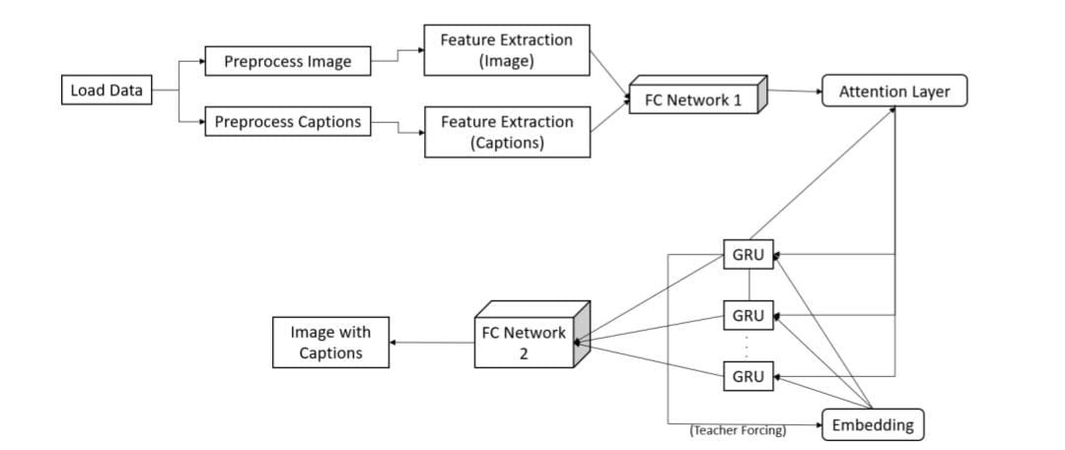**

Figure 1: Block Diagram

**6. Graph/Flowchart/Screenshot:**

**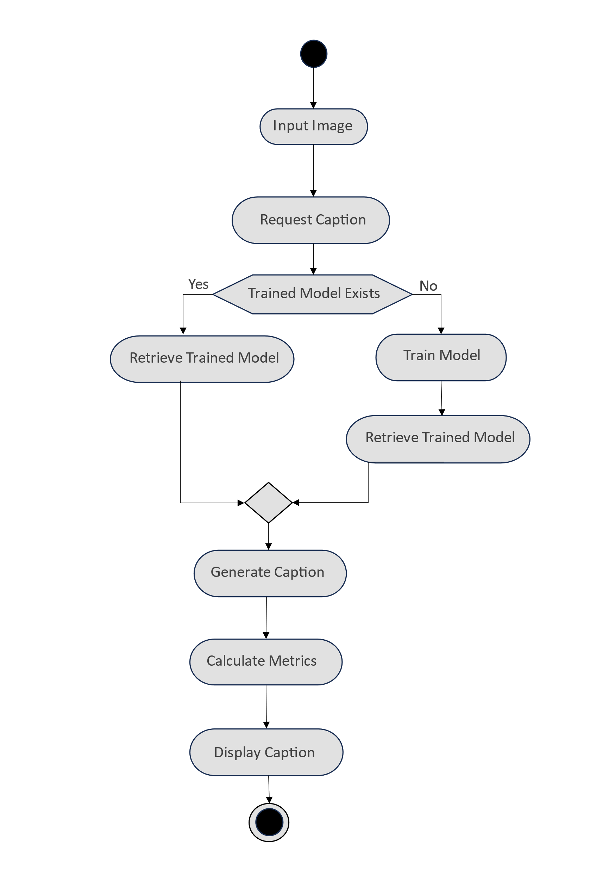**

**7. Results and Discussion:**

We proposed an efficient method to caption an image using EfficientNetV2 and GRU with BLEU score 0.576403

**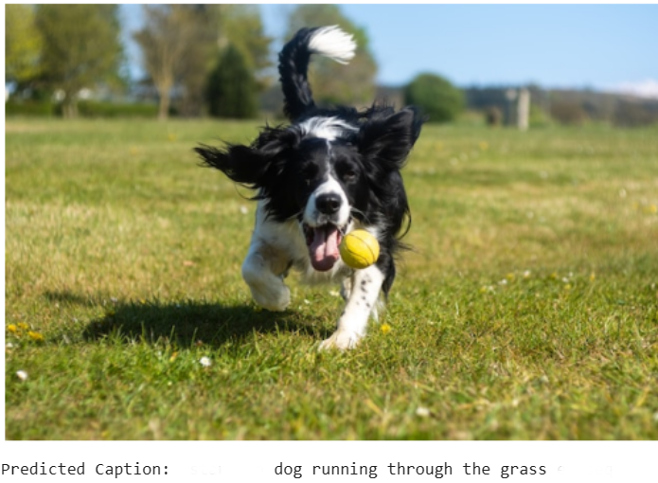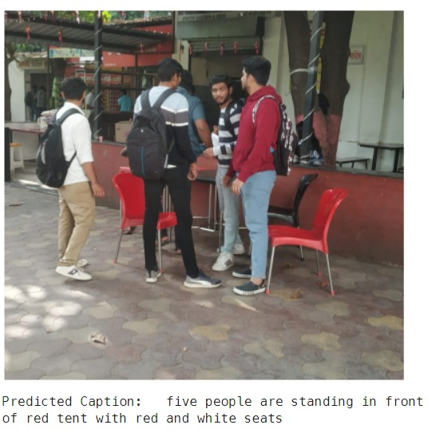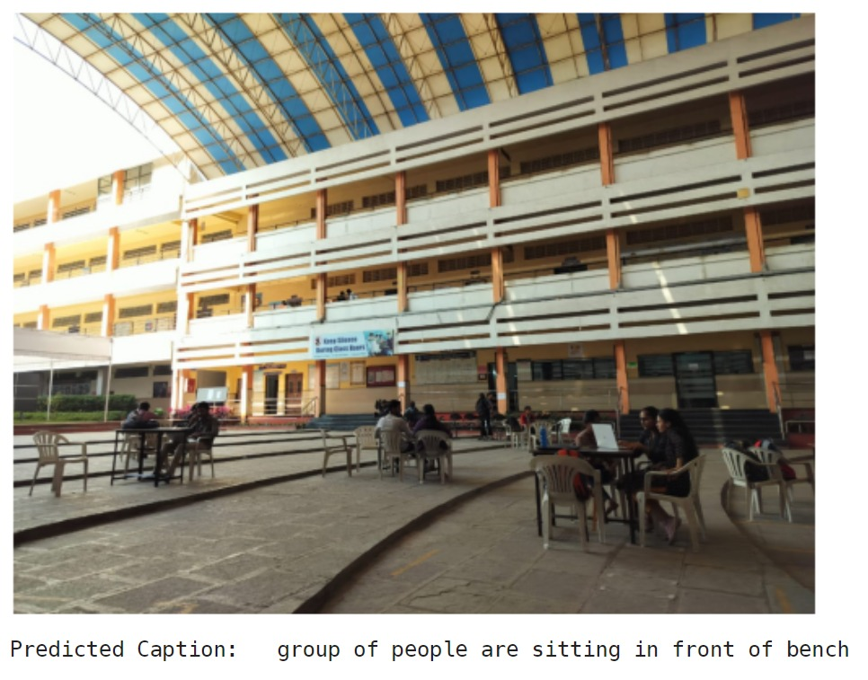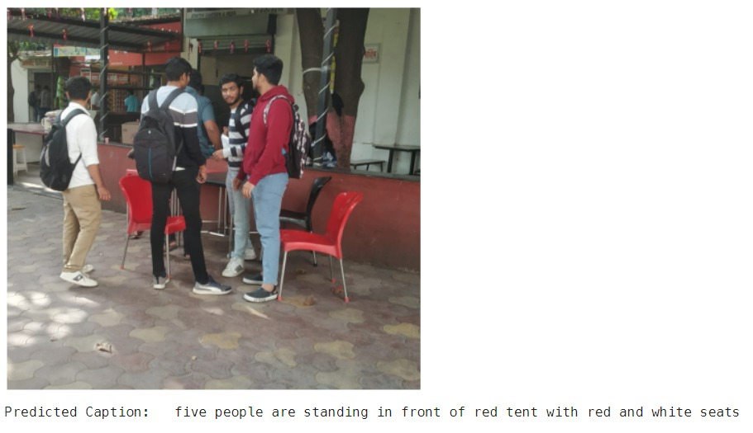**

|  |  |  |
| --- | --- | --- |
| C:\Users\LENOVO\AppData\Local\Packages\5319275A.WhatsAppDesktop_cv1g1gvanyjgm\TempState\D6D124FFDB821CC19F989F2FA5A28CE7\WhatsApp Image 2024-01-12 at 15.04.26_716eee6a.jpg | **“Image Captioning System using Deep Neural Network based on Encoder-Decoder Framework”**  **[1] Mayur Sopan Gadakh [2] Gaurav Bhima Chaudhari**  **[3] Akanksha Bhausaheb Gaikwad [4] Shivanjali Anil Dhage**  **Name of Guide**  **Mr. R. S. Gaikwad**  **Computer Engineering**  **Amrutvahini College of Engineering, Sangamner** |  |
|  |  |  |
|  |  |  |
|  |  |  |
|  |  |  |
|  |  |  |
|  |  |  |
|  |  |  |
|  |  |  |
|  |  |  |
|  |  |  |
|  |  |  |
|  |  |  |
|  |  |  |
|  |  |  |
|  |  |  |
|  |  |  |
|  |  |  |
|  |  |  |



**COMP**

**A19**

01